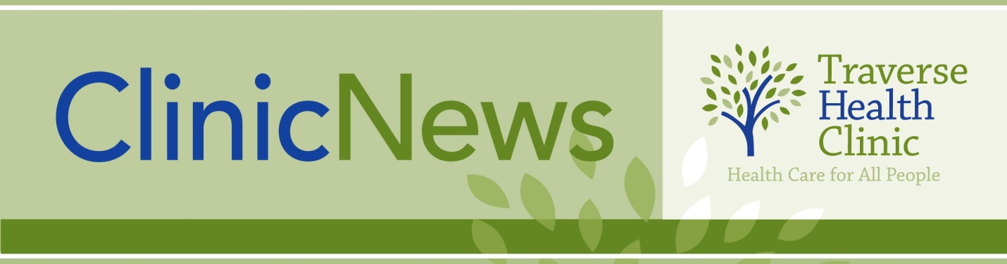
February 19, 2014
TRAVERSE HEALTH CLINIC UPDATE!
“CHAP” ends March 31st since there are now various types of coverage to help most people, but

Our Clinic Remains Open to ALL!

- Primary Care for Patients of All Ages
- Accepting Medicaid, Medicare, All Insurances, and Those Who are Uninsured
- Reduced Fees Available for Those Who Qualify

Open Monday – Friday

CALL 231-935-0799 FOR APPOINTMENT
Located off Airport Road across from Logan’s Landing

